**15CSE376**

24.07.2020 **Net Centric Programming Laboratory- Practice session II**

**Name: Duration:** 2 hours

**Roll. No: Max marks**: 20

**Evaluation scheme:**

Use of appropriate HTML tags: 10

Correct positioning of contents: 5

Output : 5

**Write HTML code to generate the mock-up webpage given below:**

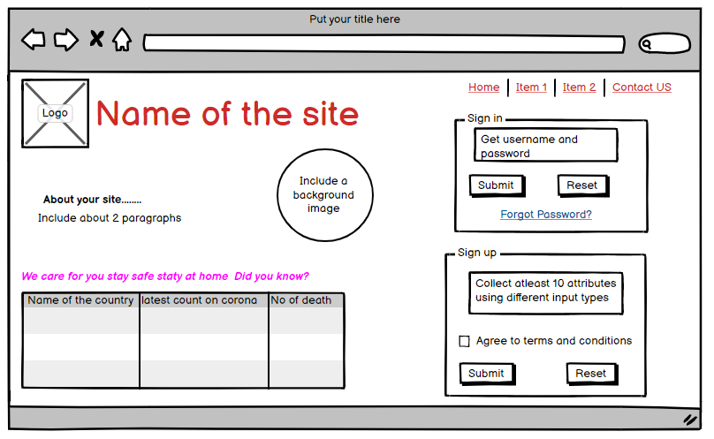

**Marks:**

|  |  |  |
| --- | --- | --- |
| **Particulars** | **Maximum marks** | **Marks awarded** |
| Usage of tags | 10 |  |
| Positioning | 5 |  |
| Output | 5 |  |
| Total | 20 |  |

Signature of the faculty: